**Data Storage and Representation**

All numerical values are stored in a computer as a series of switches turned on or off. This is represented by the binary (or base two) numbering system which contains only two digits – a zero or a one, is called a bit. A zero represents a switch that is off and a one represents a switch that is on.

**Bit**

A bit can only have two potential values: 0 or 1.

A bit refers to a digit in binary numerable system.

A bit is the smallest discrete storage unit.

Byte: a collection of 8 bits

Example 1101 1010

KB (killobyte) = 1024 bytes

MB (metabyte) = 1024 KBs

GB (gigabyte) = 1024 MBs

**Representing Integers as bit patterns**

Integers are stored as bit patterns

* 19 is stored as 10011
* 116 is stored as 1110100

Fixed-width

* 32-bit width: 19 as 0000 0000 0000 0000 0000 0000 0001 0011 (with many leading 0s)

Number of representable integers = number of bit patterns

* 32 bit width representation has 232  =4,294,967,296 bit patterns, namely 4,294,967,296 integers

To convert, or map, between binary and decimal, you must know the value of the powers of two up to one less than the number of bits used to store an integer. On the table below, the first row are decimal numbers, the second row the value as a power of two.

|  |  |  |  |  |  |  |  |  |  |  |  |  |  |  |  |
| --- | --- | --- | --- | --- | --- | --- | --- | --- | --- | --- | --- | --- | --- | --- | --- |
| 32768 | 16384 | 8192 | 4096 | 2048 | 1024 | 512 | 256 | 128 | 64 | 32 | 16 | 8 | 4 | 2 | 1 |
| 215 | 214 | 213 | 212 | 211 | 210 | 29 | 28 | 27 | 26 | 25 | 24 | 23 | 22 | 21 | 20 |

**Decimal number**

* Base 10
* Each digit corresponds to escalating powers of 10.

**Binary numbers**

A binary number

* Base 2
* Each digit corresponds to escalating powers of 2.
* Below is an illustration of a mapping from decimal to binary representation

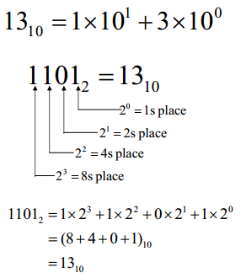

**To convert from decimal to binary:**

From the decimal number, subtract the largest power of two possible. Continue subtracting the largest power of two possible until the difference is zero. To write the binary number, write a zero for each power not subtracted and a one for each power subtracted.

For example: 80910 = 0011 0010 10012

809 – 512 = 297

297 – 256 = 41

41 – 32 = 9

9 – 8 = 1

1 – 1 = 033333

|  |  |  |  |  |  |  |  |  |  |
| --- | --- | --- | --- | --- | --- | --- | --- | --- | --- |
| 512 | 256 | 128 | 64 | 32 | 16 | 8 | 4 | 2 | 1 |
| 1 | 1 | 0 | 0 | 1 | 0 | 1 | 0 | 0 | 1 |

Where the first row represents the power of twos and the second row represents on (used) or zero (not used).

**To conversion from binary to decimal:**

To convert from binary to decimal, add all potential values that are represented by 1’s in the binary number.

For example: 0110 0011 10112 = 1595

|  |  |  |  |  |  |  |  |  |  |  |  |
| --- | --- | --- | --- | --- | --- | --- | --- | --- | --- | --- | --- |
| 2048 | 1024 | 512 | 256 | 128 | 64 | 32 | 16 | 8 | 4 | 2 | 1 |
| 0 | 1 | 1 | 0 | 0 | 0 | 1 | 1 | 1 | 0 | 1 | 1 |

Where the first row represents the power of twos and the second row represents on (used) or zero (not used).

0 + 1024 + 512 + 0 + 0 + 0 + 32 + 16 + 8 + 0 + 2 + 1 = 1595

**Hexadecimal Number Representation**

Base 16

The hexadecimal numbering system has 16 valid digits, ), 1, 2, 3, 4, 5, 6, 7, 8, 9, A, B, C, D, E, and F; A represents a decimal 10, B represents a decimal 11, C represents a decimal 12, D represents a decimal 13, E represents a decimal 14, and F represents a decimal 15.

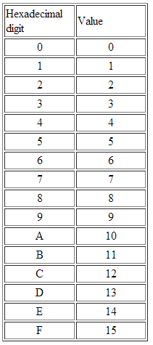

**Conversion between binary and hexadecimal:**

There is a relationship between binary and hexadecimal that make conversions between these two bases convenient. Any hexadecimal digit can always be written as a four bit binary number. These 4 bits are always the first four base two positional values 8, 4, 2, and 1.

For example: A16 = 1010 = 10102.

**To convert from hexadecimal to binary:**

Replace each hexadecimal digit with a group of four equivalent binary digits. Make sure you always include leading zeros, if necessary.

For example: 3A716 = 0011 1010 01112

_3_ __A_ __7__

0011 1010 01112

**To convert from binary to hexadecimal:**

Group the binary digits in groups of four, starting at the base point (right end of the value). Replace each binary group with a single, equivalent hexadecimal digit. If necessary, add extra zeros to the left end of the value to complete the group of four binary digits.

For example: 101110101112 = 5D716

0101 1101 01112

13

5 D 716

**To Convert from Hex to decimal:**

Hexadecimal operates the same way. Each digit is "weighted" by a "multiplier," with the results all added together. The multipliers in both systems are the powers of the system base (10 or 16). The powers of 10 are 1, 10, 100, 1000, etc. while those of 16 are 1, 16, 256, 4096, etc.

Decimal to Decimal Conversion Hex to Decimal Conversion

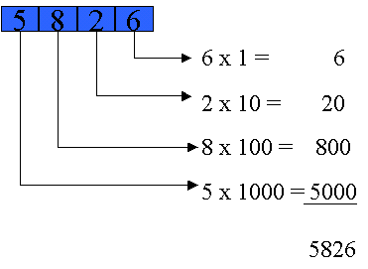 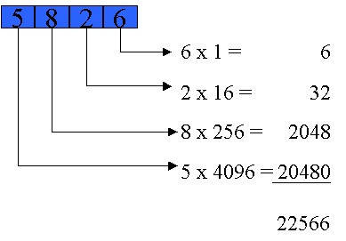

**To Convert from Decimal to Hex:**

**EXAMPLE CONVERSION - DECIMAL TO HEX**

|  |  |
| --- | --- |
| Decimal | Hex Equivalent |
| 39,619 | 9AC3 |

|  |  |  |  |  |  |  |  |
| --- | --- | --- | --- | --- | --- | --- | --- |
| Hex=Decimal | Comment | Divide decimal number successively by 16 | Remainder still in decimal | Hex Equivalent of remainder | | | |
| 0=0 1=1 2=2 3=3 4=4 5=5 6=6 7=7 8=8 9=9 A=10 B=11 C=12 D=13 E=14 F=15 |  |  |  | col 3 | col 2 | col 1 | col 0 |
| divide decimal number to be converted by 16 and put the remainder in col 0 | 39619 ÷ 16 = 2476 | * rem 3 |  |  |  | 3 |
| divide answer from row above by 16 and put the remainder in col 1 | 2476 ÷ 16 = 154 | rem 12 |  |  | C |  |
| divide answer from row above by 16 and put the remainder in column 2 | 154 ÷ 16 = 9 | rem 10 |  | A |  |  |
| divide answer from row above by 16 and put the answer in column 3 | 9 ÷ 16 = 0 | rem 9 | 9 |  |  |  |
| Write out the answer, starting with column 3 and going through to column zero. | Answer is Hex 9AC3 | | | | | |

**Physical Storage Representation**

